**Task Description: -** Your task is to comprehensively analyze how PhonePe, a leading digital payments platform, successfully captured a significant market share through its "all-in-one QR" strategy. This strategy enables merchants to accept payments from multiple sources (e.g., UPI, credit/debit cards, wallets) through a single QR code, thereby simplifying the payment process and increasing convenience for merchants and customers.

1. **Market Analysis:**  Research the digital payments market in India, including key players, market size, and growth trends. Analyze the competitive landscape and identify the positioning of PhonePe relative to other payment platforms.

**Ans:-**

**1. Introduction:-**

India's digital payments market has grown significantly, with over 40% of all payments being digital and UPI (Unified Payments Interface) accounting for a large share of those. In 2022, UPI processed over $1 trillion in digital transactions, which is about a third of India's total GDP. Objective of the analysis: Research key players, market size, and growth trends.

**2. Data Collection :-** I have been collected data from NPCI website . collected of year 2021 and 2022

**3. Key Players in the Indian Digital Payments Market:-**

PhonePe is India's leading digital payments platform, according to the National Payments Corporation of India (NPCI). In March 2021, PhonePe became the first digital payments platform to cross 1 billion monthly transactions on UPI, and as of October 2021, it had processed over 2 billion monthly transactions on its platform

**PhonePe identified as the key player with the highest market share till 2023 (46.01%).**

**4. Market Size and Growth Trends**

The total digital payment transactions volume in India has increased from 2,071 crore in FY 2017-18 to 13,462 crore in FY 2022-23 at a Compound Annual Growth Rate (CAGR) of 45%. The value of Unified Payments Interface (UPI) transactions has also grown from ₹ 1 lakh crore in FY 2017-18 to ₹ 139 lakh crore in FY 2022-23 at a CAGR of 168%.

**Government Initiatives:** Initiatives like Digital India and demonetization drive, along with programs such as PMJDY and UPI, promote digital transactions.

**Technological Advancements:** Increased smartphone adoption, high-speed internet availability, and innovative payment solutions like UPI and mobile wallets have made digital payments more accessible and user-friendly.

**Financial Inclusion:** Digital payment solutions are promoting financial inclusion by providing access to banking and financial services to underserved populations, particularly in remote areas.

**Regulatory Support:** Regulatory measures by RBI and other authorities, such as interoperability mandates and cybersecurity standards, instill trust and confidence among users in digital payment systems.

Digital Payment Market size till 2022 is $1,460 million.

**5. Competitive Landscape Analysis**

PhonePe's dominance as the leading player in the market with a 46.01% market share till 2023, followed by Google Pay.

**6. Positioning of PhonePe:**

Positioning of PhonePe is leading in digital payment market. PhonePe having highest market share in Digital Payment Market. Another competitors in market is only one Google pay . at a time toughest competitors in market is only Google pay.

**As of 2022 data :**

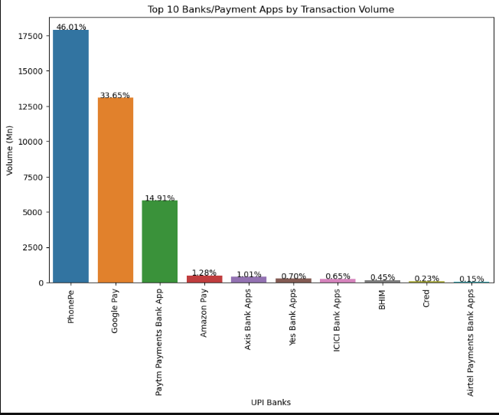

PhonePe having 46.01 % market share in Digital Payment . PhonePe Leading in market .2nd is Google Pay in Digital Payment which is having 33.65 % market share as of 2022 Data.

**7. Conclusion**

Conclusion of this task is India's digital payments market has surged, led by PhonePe capturing a 46.01% market share till 2023, followed by Google Pay. Government initiatives and technological advancements have spurred growth, with PhonePe emerging as a frontrunner. With its user-friendly interface and extensive reach, PhonePe is reshaping India's financial landscape, marking a significant milestone in digital payment evolution.

1. **QR Code Strategy:**
2. **Investigate PhonePe's "all-in-one QR" strategy, including its features, functionality, and implementation process**.
3. **Explore how this strategy simplifies the payment acceptance process for merchants and enhances the user experience for customers.**

**Ans:-**

**Features:**

**Unified Payment Methods**: The all-in-one QR integrates various payment methods, including UPI, debit/credit cards, and digital wallets, into a single QR code.

**Simplified Acceptance:** Merchants only need one QR code to accept payments from multiple sources, eliminating the hassle of managing separate codes for different methods.

**Enhanced User Experience:** Customers enjoy a seamless payment experience, choosing their preferred method without switching apps or devices.

**Increased Accessibility:** By supporting multiple payment options, PhonePe's QR code expands the acceptance of digital payments, catering to a broader customer base.

**Functionality:**

**Seamless Transactions:** Customers scan the QR code and select their preferred payment method, completing the transaction swiftly.

**Streamlined Operations:** Merchants display the QR code at their point of sale, simplifying payment acceptance and reducing operational complexity.

**Secure Transactions:** All transactions conducted through the QR code are encrypted, ensuring the safety of sensitive financial data.

**Implementation Process:**

**Merchant Onboarding:** PhonePe provides merchants with the necessary tools and support to onboard onto the platform and generate their unique all-in-one QR code.

**QR Code Deployment**: Once onboarded, merchants receive their QR code, which they can display at their business premises for customers to scan and make payments.

**Customer Experience:** Customers scan the QR code using the PhonePe app or any other UPI-enabled app, choose their preferred payment method, and complete the transaction seamlessly.

**Impact:**

**Simplified Payments:** The all-in-one QR strategy simplifies the payment acceptance process for merchants, reducing operational complexity and enhancing efficiency.

**Enhanced User Experience:** Customers benefit from a seamless payment experience, leading to higher satisfaction and increased loyalty.

**Increased Adoption:** The accessibility and convenience offered by PhonePe's QR code strategy drive adoption and usage of digital payments among merchants and customers.

1. **Merchant Adoption:**
2. **Assess the factors that contributed to the widespread adoption of PhonePe's QR code among merchants.**
3. **Analyze the benefits offered to merchants, such as faster settlements, access to business insights, and promotional opportunities**

**Ans:- One of the main reason is PhonePe giving best service of merchant like Ex:- PhonePe’s POS Device is very chepeast compare to other POS devices provider .**

**PhonePe’s POS device merchant buy only 1200 ruppes as deposit. Every month Merchant pay only 249/- for POS device . as copare to other company paytm give pos device plan for 6 month and that price is 5499/-.**

**Simplified Payment Process:** PhonePe's all-in-one QR code simplifies the payment acceptance process for merchants by consolidating multiple payment methods into a single QR code. This eliminates the need for managing multiple devices or QR codes for different payment methods, reducing operational complexity.

**Convenience and Flexibility:** The QR code offers unparalleled convenience and flexibility to merchants, allowing them to accept payments via various methods, including UPI, debit/credit cards, and digital wallets, using just one code. This flexibility accommodates diverse customer preferences and enhances the overall payment experience.

**Easy Integration:** PhonePe provides merchants with seamless integration of the QR code into their existing payment infrastructure. With user-friendly onboarding processes and technical support, merchants can quickly deploy the QR code at their point of sale without significant investment or technical expertise.

**Enhanced Security Measures:** PhonePe prioritizes security and reliability in its QR code solution, ensuring that transactions conducted through the code are encrypted and protected against fraud or unauthorized access. This instills confidence among merchants regarding the safety of their transactions and sensitive financial data.

**Marketing and Awareness Initiatives:** PhonePe has undertaken extensive marketing and awareness campaigns to promote its QR code solution among merchants. By highlighting the benefits and ease of use of the QR code, PhonePe has effectively communicated its value proposition to merchants, driving adoption and usage.

**Customer Demand:** As digital payments gain traction among consumers, merchants are compelled to adopt convenient and secure payment solutions to cater to customer preferences. PhonePe's QR code addresses this demand by offering a seamless and versatile payment option, driving merchant adoption.

**Conclusion:-** PhonePe's QR code gained popularity among merchants due to its simplicity, accommodating various payment methods in one code. Easy integration, strong security, and marketing efforts further encouraged adoption. Rising consumer demand for digital payments also drove merchants to embrace this convenient and versatile solution.

1. **Customer Engagement:**
2. **Examine how PhonePe incentivizes customers to use their platform for transactions.**
3. **Evaluate the user experience of making payments through PhonePe's QR code and its impact on customer retention**

**Ans:-** 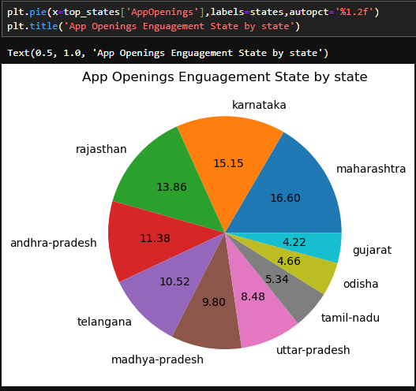

**This pie chart show the App opening enguagement in different different state by state . using this chart and data we can easily see the maharashtra state user’s oppen app and scan qr more number of times compare to other states user.**

**Note:- use can see details information in my jupyter notebook file.**

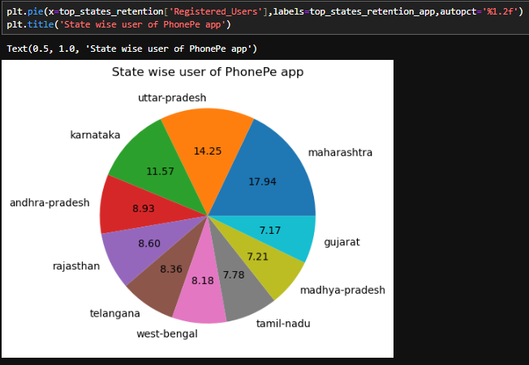

**This pie chart show number of PhonePe are which state. Here we can easily see the 17.94 percentage user from the Maharashtra . followed by Uttar Pradesh and Karnataka.**

**Note:- use can see details information in my jupyter notebook file.**

**Conclusion:-**

**Incentive Mechanisms:** PhonePe strategically employs various incentives such as cashback offers, discounts, and rewards programs to encourage customers to use their platform for transactions. By providing tangible benefits to users, PhonePe incentivizes frequent usage and fosters loyalty among its customer base.

**User Experience Enhancement:** The user experience of making payments through PhonePe's QR code is seamless and convenient, contributing to high levels of customer satisfaction and retention. The simplicity and efficiency of the QR code payment process reduce friction for users, making it easier and more appealing for them to choose PhonePe for their transactions.

**5. Network Effects:-**

**1. Explore the network effects created by PhonePe's expanding merchant base and user adoption.**

**2. Analyze how the interconnected ecosystem of merchants and customers contributes to PhonePe's market dominance.**

**Ans:-** As PhonePe's merchant base grows, so does its utility for both businesses and customers. With more merchants onboard, customers enjoy a wider acceptance of PhonePe, enhancing their experience and driving further adoption.

The interconnected ecosystem of PhonePe facilitates cross-selling between merchants and customers, fostering increased patronage and sales. This data-driven approach allows PhonePe to tailor its offerings, enhancing its relevance and appeal to users.

Furthermore, PhonePe's expanding ecosystem creates a network lock-in effect, making it challenging for competitors to displace the platform. This solidifies PhonePe's position as a leading player in the digital payments market.

1. **This pie chart show the year -2018’s payment in which category and how many percentage payment in which category** .

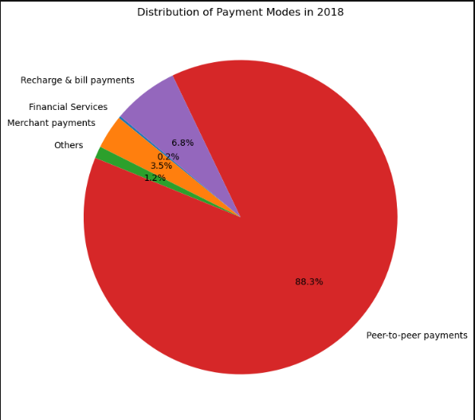

1. **This pie chart show the year -2019’s payment in which category and how many percentage payment in which category** .

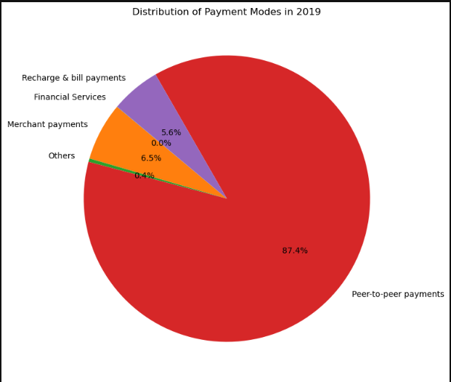

1. **This pie chart show the year -2020’s payment in which category and how many percentage payment in which category** .

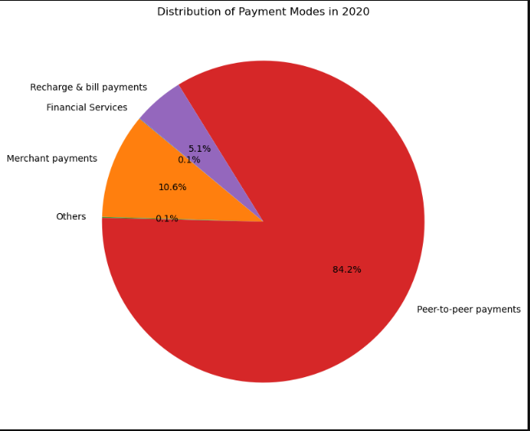

1. **This pie chart show the year -2021’s payment in which category and how many percentage payment in which category** .

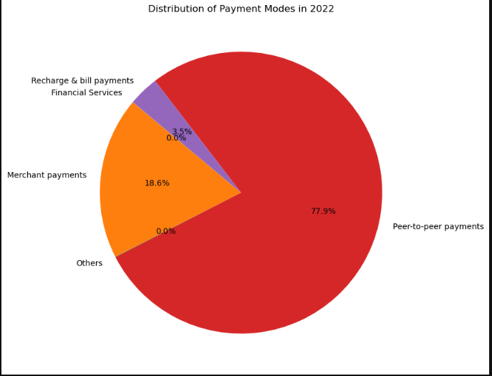

**Conclusion :- after showing this 4 chart we can see more number of payment in peer to peer payments category. We can also see continuously increasing merchant payments category because after launching one qr statragy increasing. Now new trends is the Merchant payments category . also continuously increasing the digital market volums.**

**7. Strategic Recommendations:**

**1 . Based on your analysis, provide strategic recommendations for sustaining and further expanding PhonePe's market leadership**.

**2. Propose innovative features or enhancements to the QR code strategy to maintain a competitive edge in the evolving digital payments landscape.**

**Ans:- as of my opinion and analysis company should work on new technology for increase user experience, user convinious also work on customer services and security etc.**

**Innovate with Technology:** Continuously invest in new technologies to enhance user experience and convenience. Incorporate features like faster transactions, smoother navigation, and personalized recommendations to keep users engaged. Implement new technology like Artificial Inteligence and Machine Learning and Cyber security for improve security **.**

**Prioritize Customer Service:** Improve customer service channels and responsiveness to address user queries and concerns promptly. Offering proactive assistance and quick resolutions can enhance user satisfaction and loyalty.

**Focus on Security:** Strengthen security measures to safeguard user data and transactions. Implement robust encryption protocols, multi-factor authentication, and regular security audits to instill trust and confidence among users.

**Streamline Processes:** Simplify user interfaces and payment processes to make transactions seamless and intuitive. Minimize steps required for transactions and ensure compatibility across various devices and platforms.

**Enhance Merchant Support:** Provide merchants with comprehensive tools and resources to optimize their experience with PhonePe. Offer analytics insights, marketing support, and streamlined onboarding processes to encourage merchant adoption and engagement.

**Foster Innovation:** Foster a culture of innovation within the company to continuously explore new ideas and technologies. Encourage experimentation and collaboration to stay ahead of evolving market trends and customer needs.

**Embrace Emerging Technologies:** Embrace emerging technologies such as AI and machine learning to personalize user experiences and drive engagement. By analyzing user data and behavior patterns, PhonePe can offer targeted recommendations and promotions, increasing user satisfaction and loyalty.

**Invest in Security:** Prioritize security measures to protect user data and financial transactions. Implement robust encryption protocols, multi-factor authentication, and proactive monitoring systems to safeguard against potential security threats and ensure trust and confidence among users.

**Reference For this Data Analyst Assignment**

1. **PhonePe Plus:-**  [**https://www.phonepe.com/pulse/explore/transaction/2020/1/**](https://www.phonepe.com/pulse/explore/transaction/2020/1/)
2. **Kaggle For Data Science:** [**https://www.kaggle.com**](https://www.kaggle.com)
3. **Chat-GPT :-** [**https://chat.openai.com**](https://chat.openai.com)
4. **Git -Hub :- https://github.com**
5. **Statista :-** [**https://www.statista.com**](https://www.statista.com) **and number of articals of PhonePe’s Press.**

**NOTE:- other material of my tasks is available on git hub repository . for see jupyter files and data you can click on given github link or google drive Link**

**Git-Hub Link:-** [**https://github.com/Harsh772005/Wiz-Developers-Data-Analyst-Task**](https://github.com/Harsh772005/Wiz-Developers-Data-Analyst-Task)

**Google Drive Link :-** [**https://drive.google.com/drive/folders/1qohZrddN5XSTy9WzJ5-V5fByEVuUcdwy?usp=sharing**](https://drive.google.com/drive/folders/1qohZrddN5XSTy9WzJ5-V5fByEVuUcdwy?usp=sharing)

**Contact No. :- +91 7572865685**

**Email:-** [**harshbhanushali7705@gmail.com**](mailto:harshbhanushali7705@gmail.com)

**Prepared by Harsh Bhanushali if you have any doubt you can contact me directly.**